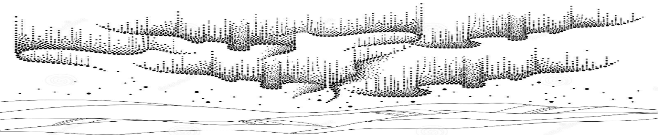
PROGRAM AURORA (Sensory focus)
This program is designed to provide each child with a safe and nurturing environment that will stimulate learning. It will be a highly adaptable routine that allows the focus to be on sensory stimulation, emotional exploration, and movement.
Visual exploration will be introduced. Children will have access to over head lights, lights at eye level as well as lighting that can be touched and held. Black lighting as well as LED lights are present for play. Bubble tubes, lava lamps, glowing balls as well as touch button lights are present for children to interact with as well.
Our little one’s will be introduced to sound that is brought on by touch. Cause and effect toys will be used with this program. Adaptive toys will also be available to cater to the child’s specific abilities and mobility. Different textures will be explored regularly.
Children will be guided to express emotions such as happiness, sadness and anger. Spending time stretching and strengthening muscles and joints.
We will work with these children to discover their means of communication through their current abilities and skills. We will practise complete comprehensive coordinated care for children in this program to ensure that they are using their skills to the best of their abilities. Children in this program will begin to discover their gifts and talents. We will provide advanced strategies to encourage alternative communication, promote desensitization, as well as reduce sensory overload in certain situations and settings.
Children who are involved in Program Aurora will not have goal-based expectations. It will be adaptable and flexible. Goals will be added for each child individually.
Activity examples: Books, playing with lights and light reactive toys, cause and effect toys, sensory bins, music exploration, exercise and stretching games, instrument introduction as well as art and crafts.

Lavender Smiles Daycare Inc. Saskatoon, SK 2021

