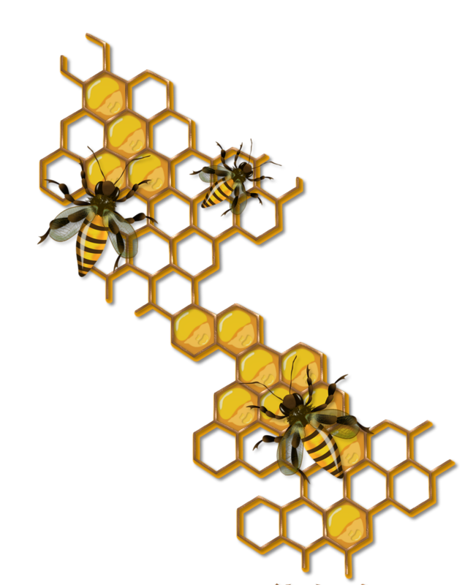
PROGRAM BUMBLE BEE (Beginning steps)
Program Bumble Bee is a goal-based program in which the child will develop their social, fine motor, and gross motor skills through progressive learning and exploration. Strong speech and language skills will be introduced on a regular basis to prepare the children for literary skill development. Emotional control will begin to be fine tuned and regulated. Children in Program Bumblebee will be encouraged to explore and develop their newfound skills.
Core language skills will be built and worked on consistently alongside augmentative and alternative communication. These aides will be placed around the house to encourage children to convey their needs and wants throughout the day. Picture Exchange Communication System (PECS) boards will be available as well as core communication boards. Sign language will be introduced to children who may benefit from it and used alongside the communication aides. Multiple ways to convey their needs will assist the child to discover a type of language that will work for them.
The concept of dramatic center play will be introduced which will encourage imagination and creativity. Encouraging children to use their imagination creates a sense of independence and a desire to explore their surroundings on a deeper level.
Children will be challenged to discover new skills and abilities. You will see your child develop new language skills alongside a sense of confidence and independence. Children are encouraged every step along the way and are taught that mistakes are how we learn. Lessons will be incorporated throughout daily activities and games. Language skills will begin to present themselves and further develop. Children will meet their set goals throughout this program and carry on making new ones.

Lavender Smiles Daycare Inc. Saskatoon, SK 2021

